**BY: ANDREW TIAN**

**LAB GOAL**: Figure out how to tear down the entire fort made by poachers and collect all the flowers. This does not require a loop, only methods.

**LAB DESCRIPTION**: Several Jeroos have been kidnapped by poachers and are being held at Fort Wallabolong (hey, it’s Australia alright?) and want to escape. In an act of vengeance, the Jeroos plan on destroying the fort as well so future animals cannot be captured.

**START**



**ENDING**

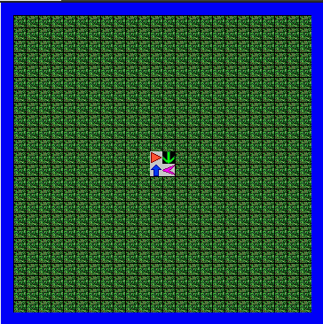

**REQUIREMENTS**

-Use Methods

-All Flowers and Nets must disappear

-Jeroo Cannot Die or Collide with any other Jeroo